1. **GPS positioning You need to align the face in Figure 1 with SKY for positioning**

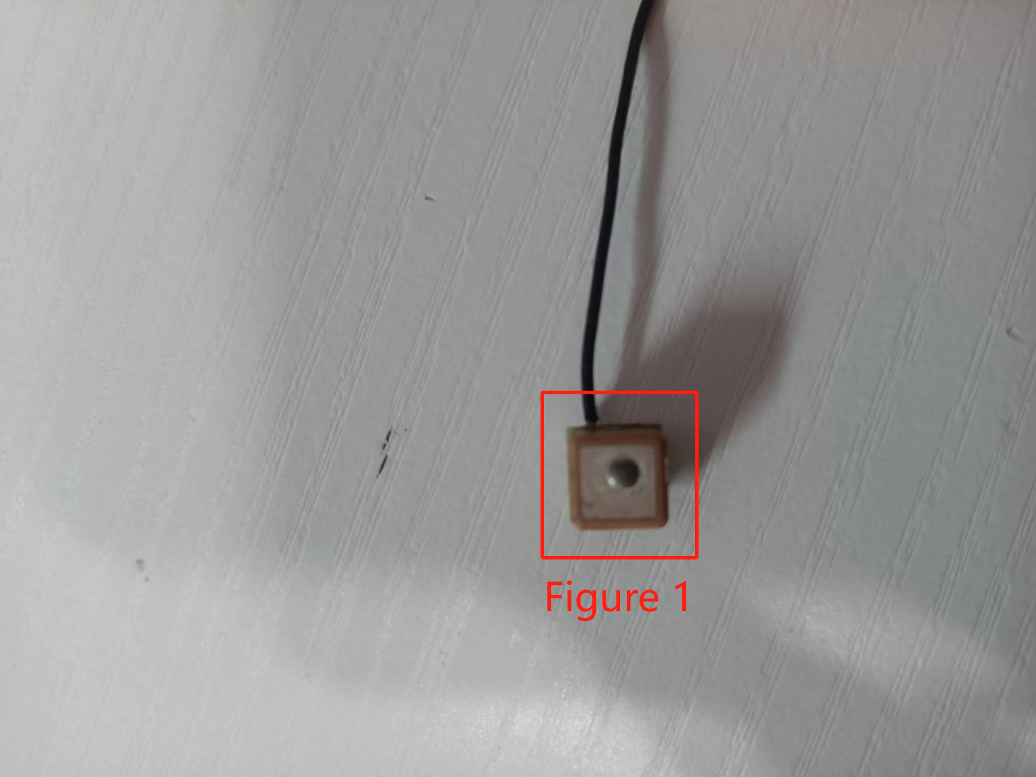

2. The object needs to be placed as shown in Figure 2 and pointed towards the sky for positioning

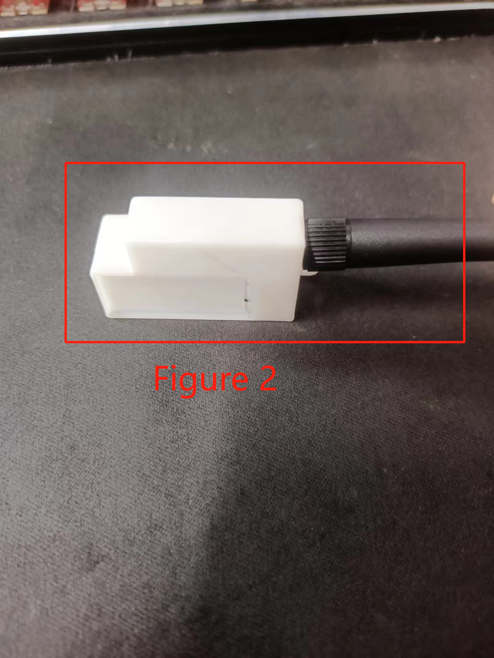

3.GPS storage location

